**Champion Locksmith - The Smart Choice**

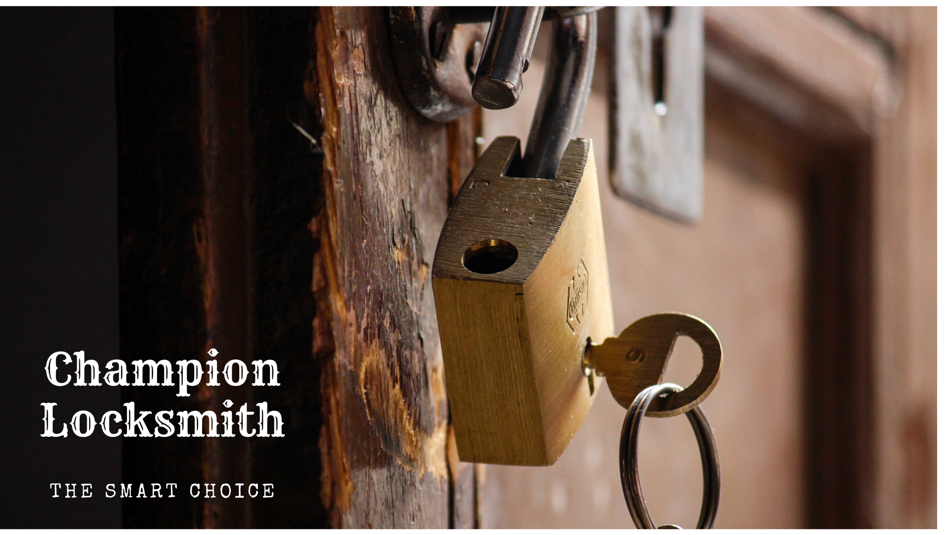

Are you searching for the best and top locksmith? Or maybe you require a domestic locksmith since you are having a problem with your locks at home? You might need a car locksmith. In every case, we are available to assist you. We can help you because we have all the necessary equipment, cutting-edge technology, and a staff of skilled and expert locksmiths. We are always the people to turn to for help, whether you just need a quick solution, like a lockout service or a security upgrade for your lovely home or business.

# Who Are We?

Champion Locksmith is a certified and licensed locksmith company. We provide more than just lock installations, maintenance, and residential lockout services. Our professionals are available seven days a week to help you with everything you need, including activation or replacement, if you need a replacement car key immediately after being locked out of your car or vehicle or if you are constructing a new home or want to upgrade the keys on your existing property.

# Why Choose Us?

* Top Rated Locksmith Company
* Available Worldwide
* Fully Licensed and Insured
* All Technicians Have Passed Background Checks
* 100% Satisfaction
* Affordable Price

# Services:

* Solving the issue of Key Replacement
* 24/7 locksmiths
* Services to unlock the garage door and open trunks
* Picking locks on file cabinets & gates
* Replacing broken locks & misplaced keys
* Keys replication and key cutting
* Automotive transponder keys
* Installation of CCTV
* Repairing security doors
* Installing security lock
* Installation of a combination lock
* Picking locks

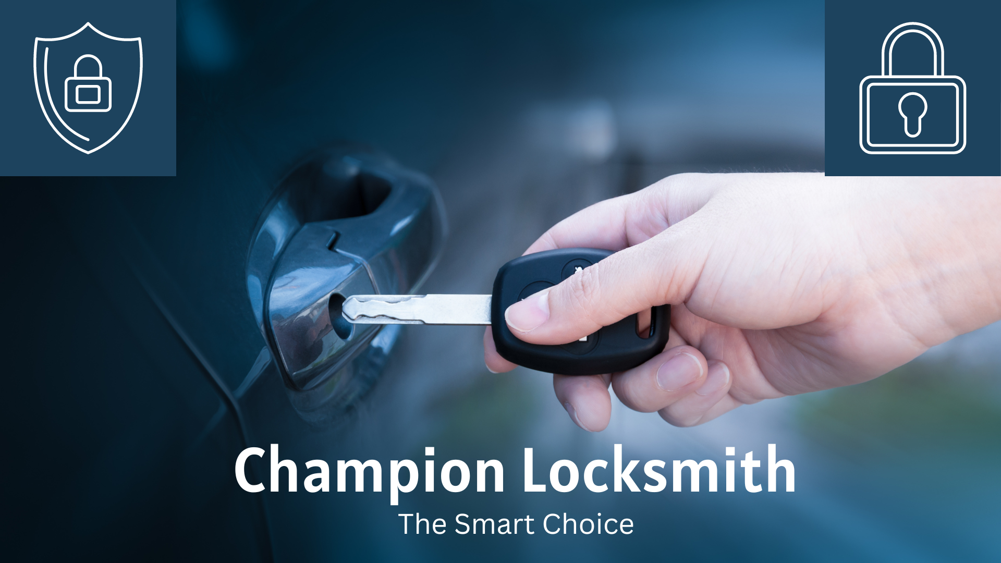

# 24/7 Emergency Lock system:

Emergencies can occur anytime, so it's always a good idea to have services accessible. We offer our locksmith service 24/7. Suppose you should ever find yourself locked in your house, automobile or office building; our skilled locksmiths are always prepared and will act immediately to open the door. Therefore, before worrying and wondering what you should do, remember that Champion Locksmith is always available and willing to help. With us, there's no such thing as "office hours."

# Car/Auto Locksmiths:

Automotive activation keys are available in a wide variety, which Champion Locksmith can manage. We provide all kinds of auto locksmith services, including replacement and essential duplication for vehicles. Our support staff members are auto locksmiths with years of training and expertise in manufacturing and installing keys for your automobiles.

**We find you everywhere if you need locksmiths.**

Since we are mobile units, we can quickly arrive at your location with all the necessary equipment. As a result, you don't need to worry once you contact us because we will handle everything else. We try so hard to provide you with the best possible service because we know the security concerns with your automobiles and other vehicles.

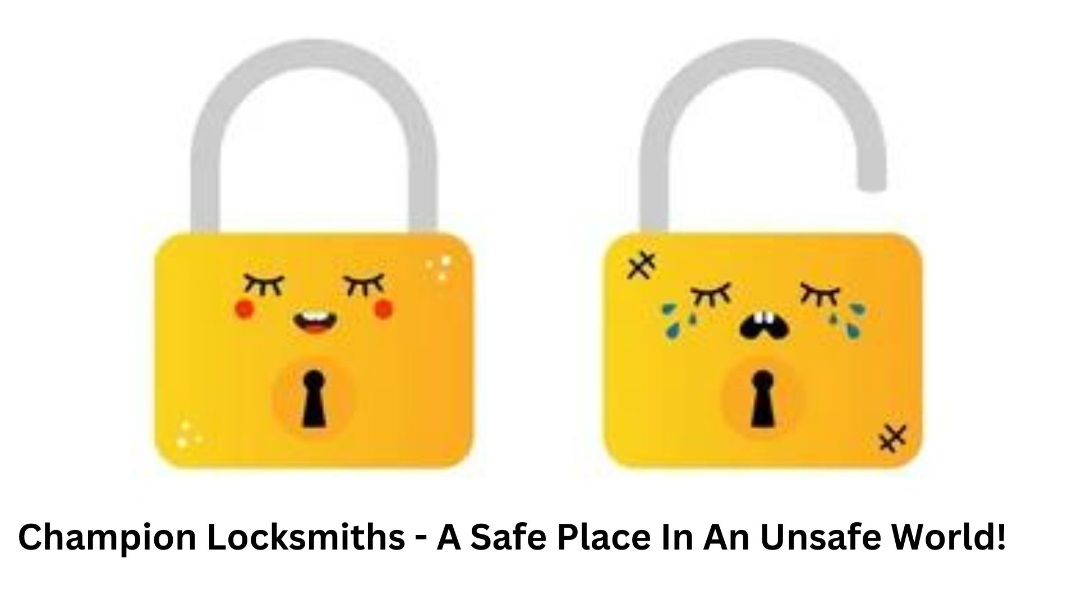

# Commercial Locksmith:

Worldwide, we already have thousands of satisfied clients using our commercial locksmith services, some of whom have become loyal followers of our business. Our commercial locksmith services include fixing broken office keys, resetting safe combinations, rekeying, installing highly secure locks and systems, repairing filing cabinets, implementing master keys, and anything else you can imagine. Every day of the week, Champion locksmith is here to help you with your emergency locksmith needs. Do not wait until the next business day to contact us if you want emergency locksmith services.

# Residential Locksmith:

If you've ever been locked out of your house, you are very well known for how irritating it can be. Of course, it's even worse if you're stuck outside in a thunderstorm. To meet your requirements, we may come and install new security door systems or have existing ones rekeyed. We finish the job swiftly, effectively, professionally, and peacefully. Our locksmiths are professional people who can work with any lock system. That indicates that the time it takes for you to return to the comfort of your house will not be too long.

# So why are you still waiting? To be safe like a champion, choose Champion.